Quiz Application using Java and SQLite
Project submitted to the
SRM University – AP, Andhra Pradesh
for the partial fulfilment of the requirements to award the degree of Bachelor of Technology
In
Computer Science and Engineering
School of Engineering and Sciences
Submitted by
Sindhuja Arnepalli – AP22110011444
Sathvik Reddy Sama – AP22110011491
Rishitha Kota – AP22110011489
Nithyasri Vadapalli – AP22119911443

Under the Guidance of
Ms. Kavitha Rani Karnena
Assistant professor, Dept.of CSE
SRM University–AP
Neerukonda, Mangalagiri, Guntur
Andhra Pradesh – 522 240
April, 2025

CERTIFICATE
Date: 24-04-2025
This is to certify that the work present in this Project entitled “Quiz Application using Java and SQLite” has been carried out by Sindhuja.A, Sathvik.R, Rishitha.K, Nithyasri.V under my supervision. The work is genuine, original, and suitable for submission to the SRM University – AP for the award of Bachelor of Technology in School of Engineering and Sciences.

Supervisor

(Signature)
Ms. Kavitha Rani Karnena
Assistant Professor,
Department of CSE

Acknowledgements
We would like to acknowledge the guidance and support provided by our mentor and advisor Ms. Kavitha Rani Karnena. Your wisdom and experience helped steer us in the right direction, and your feedback was instrumental in refining our ideas and approaches. I extend my heartfelt thanks to my team members who collaborated tirelessly, sharing their expertise and insights, and working together cohesively towards our common goal. Each of you played a crucial role in shaping the project's outcome, and I am truly grateful for your contributions. Furthermore, I am thankful for the resources and opportunities provided by our university, which enabled us to carry out this project successfully.

ABSTRACT
The Quiz Master application is an interactive Android-based quiz platform developed in Java, designed to enhance learning through engaging quizzes across diverse categories like Java, Probability, Current Affairs, and Psychometric Analysis. It features secure user authentication with sign-up/login functionalities, real-time score tracking, a leaderboard system displaying top scorers, and a personalized profile section. Users can view attempts, best scores, and profile images based on gender. The intuitive UI supports both dark and light modes, ensuring an accessible and aesthetic experience. The app utilizes SQLite for data persistence, ensuring offline access and reliable performance. Future enhancements may include score export, analytics, and quiz history features.

Table of Contents:
1. Introduction ................................................................................................................. 6
1.1 Purpose
1.2 Scope
1.3 Overview
2. The Overall Description ................................................................................................7
2.1 Product Perspective
2.2 Product Functions
2.3 User Characteristics
2.4 Constraints
2.5 Assumptions and Dependencies
3. External interface Requirements ...................................................................................8
3.1.1User Interfaces
3.1.2Hardware Interfaces
3.1.3Software Interfaces
3.1.4Communications Interfaces
4. Software System Attributes............................................................................................9
4.1 Reliability
4.2 Availability
4.3 Security
4.4 Maintainability
5. Frond-end description………………………………………………………………………………………………..10
6. Back-end description…………………………………………………………………………………………………..10
7. Results……………………………………………………………………………………………………………………11-19
8. Conclusion…………………………………………………………………………………………………………………..20

1. Introduction
1.1 Purpose
The purpose of this project is to develop a mobile-based quiz application that allows users to register, take quizzes from multiple categories, and track their performance. It aims to enhance knowledge retention through an interactive and user-friendly interface while maintaining a persistent scoring system.
1.2 Scope
This application supports user authentication, profile creation with demographic details, real-time quiz taking with a countdown timer, and result evaluation. It features a leaderboard to foster competitive learning and includes dark mode support for a visually comfortable experience. All data is stored locally using SQLite, ensuring offline functionality.
1.3 Overview
The system is divided into three main modules: user authentication, quiz engine, and performance tracking. The user interface is intuitive, designed using XML layouts, and the backend logic is implemented in Java with SQLite support. The application is responsive and follows modern UI/UX practices.

2. The Overall Description
2.1 Product Perspective
Quiz Master is a self-contained Android application developed using Android Studio. It uses standard Android components and Material Design for the interface and integrates SQLite for data persistence.
2.2 Product Functions
- User registration and login
- Quiz categories (Java, Probability, Current Affairs, Psychometric)
- Timer-based quiz interaction
- Local database to store user info and scores
- Leaderboard for top scorers per quiz
- Profile with best scores and quiz attempt count
- Gender-based avatar selection
- Logout functionality
2.3 User Characteristics
The intended users are students and knowledge seekers who want to practice quizzes on various topics. Basic familiarity with using Android smartphones is expected.
2.4 Constraints
- SQLite limits multi-device data sync.
- App performance may vary on low-end devices.
- UI limited by screen size and device resolution.
- Internet-independent (offline-only functionality).
2.5 Assumptions and Dependencies
- The app runs on Android 10 (API 29) and above.
- SQLite is pre-integrated and compatible with the device.
- Assumes Java and XML experience for maintenance.

3. External Interface Requirements
3.1.1 User Interfaces
- Login and Signup Screens
- Quiz selection and question layout
- Leaderboard with section-wise scores
- Profile with optional avatar and user stats
- More screen for future enhancements
3.1.2 Hardware Interfaces
- Android Smartphone with a minimum of 1 GB RAM and 50 MB storage
3.1.3 Software Interfaces
- Android OS (10+)
- SQLite database
- Java 11 for application logic
- Android Jetpack libraries (UI/UX)
3.1.4 Communications Interfaces
- Currently, no external communication; all data is handled locally.

4. Software System Attributes
4.1 Reliability
The app uses try-catch blocks and validation to prevent crashes. It handles missing inputs and incorrect data gracefully.
4.2 Availability
The application is always available on the user's device since it does not depend on internet connectivity.
4.3 Security
User credentials are stored securely. SharedPreferences is used only for non-sensitive information (e.g., current session username).
4.4 Maintainability
The code is modularized by separating DBHelper, Activities, and Fragments. The use of standard Android architecture makes it maintainable and scalable.

5. Front-end Description
The front-end is designed using XML and Material Design components. It includes:
- CoordinatorLayout for screen hierarchy
- Buttons with color-coded themes
- Recyclerview for the leaderboard
- Spinner for gender selection
- ImageView for profile avatars

6. Back-end Description
The back-end is built entirely in Java. It uses:
- SQLiteOpenHelper (DBHelper.java) for all CRUD operations
- SharedPreferences for user session management
- Custom classes and methods for handling quiz logic, score storage, and profile management

7. Results
The app functions smoothly with accurate data storage and retrieval. It maintains user sessions, records all scores, updates leaderboards dynamically, and supports gender-based profile image display.
Images:
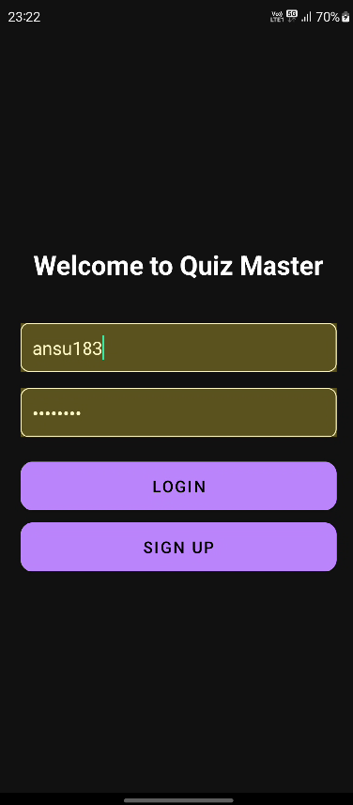

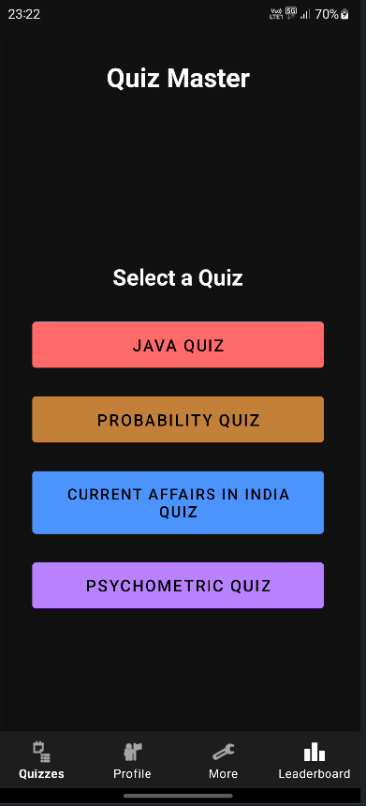

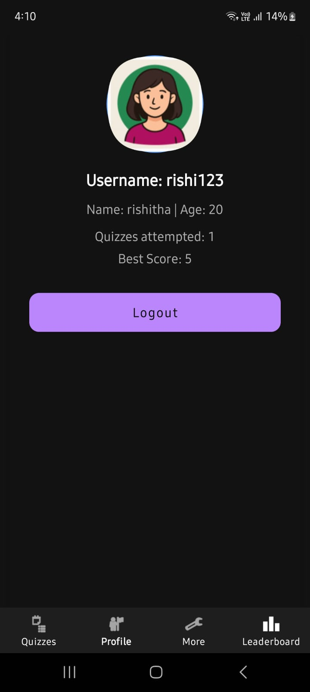



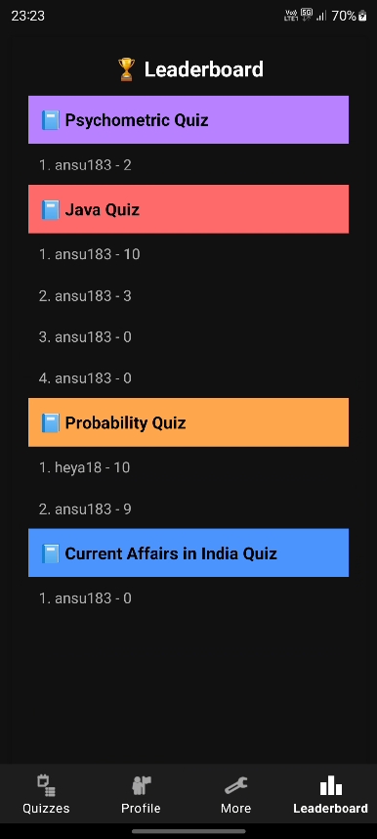

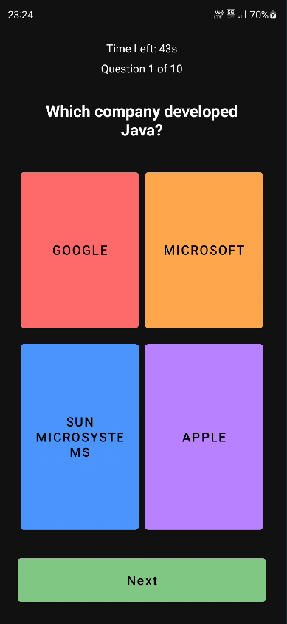

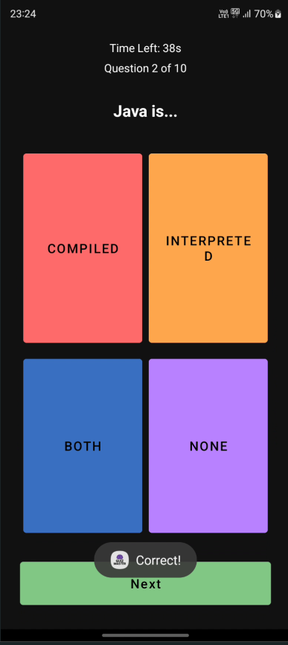

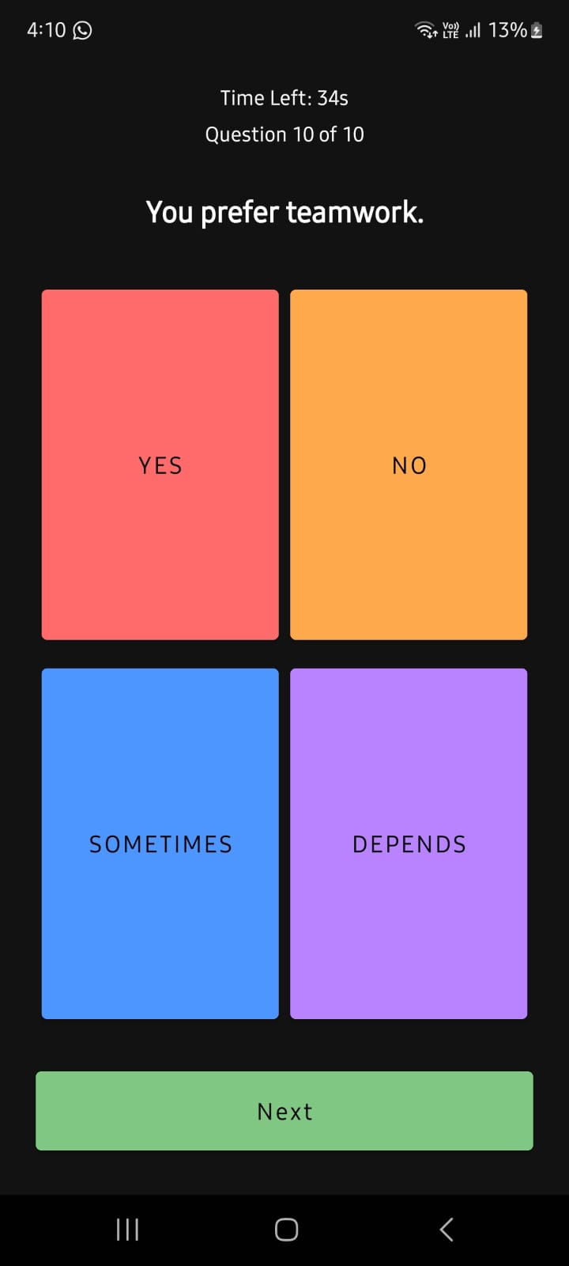
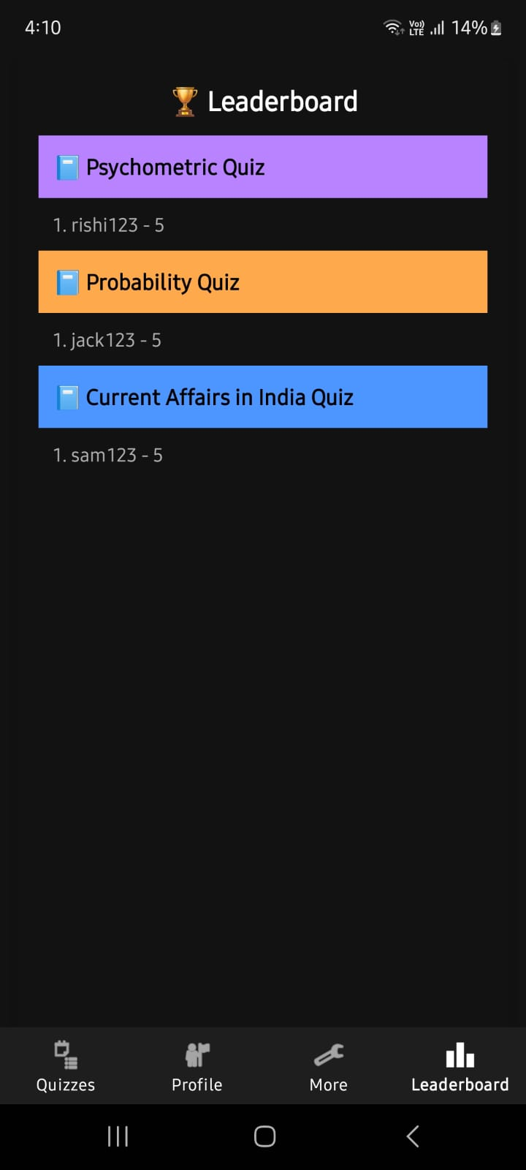
8. Conclusion
Quiz Master achieves its goal of being an educational and engaging quiz platform. It combines user-friendly design with offline capabilities, making it a suitable tool for practice and learning across various topics.

